## Reports Menu/Pseudoephedrine/Patient Summary:

Request: 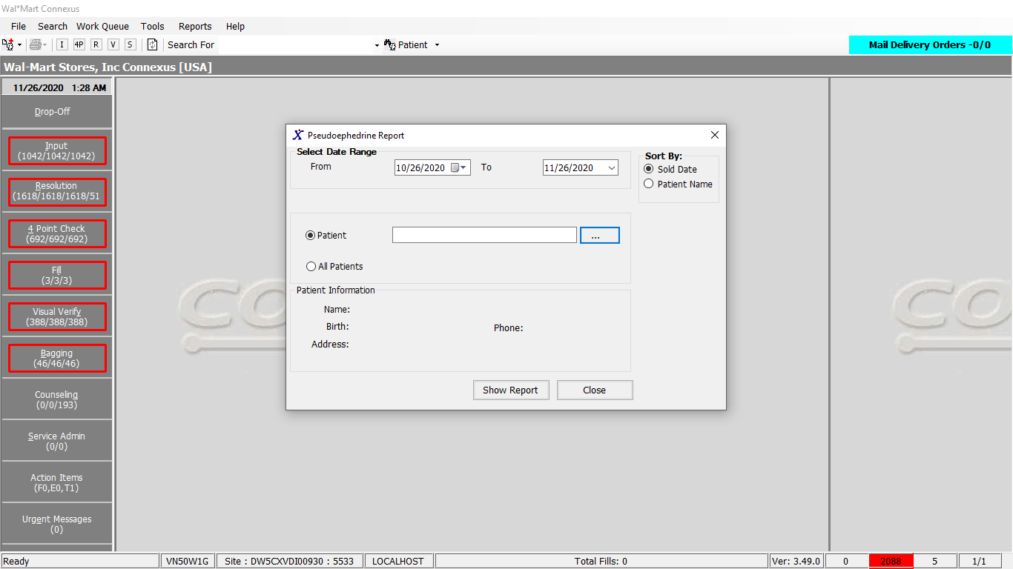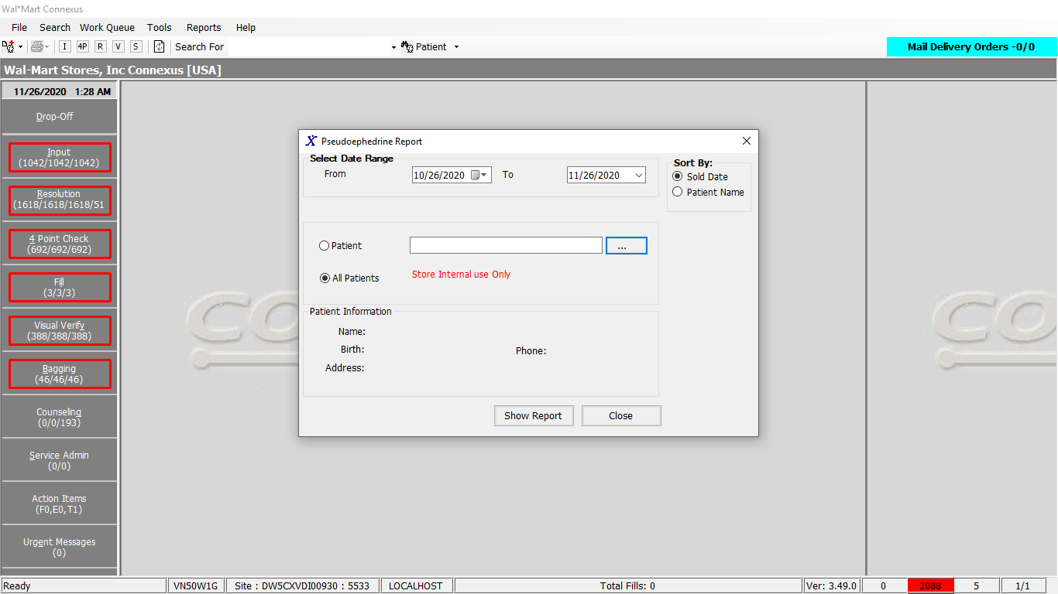

Response:

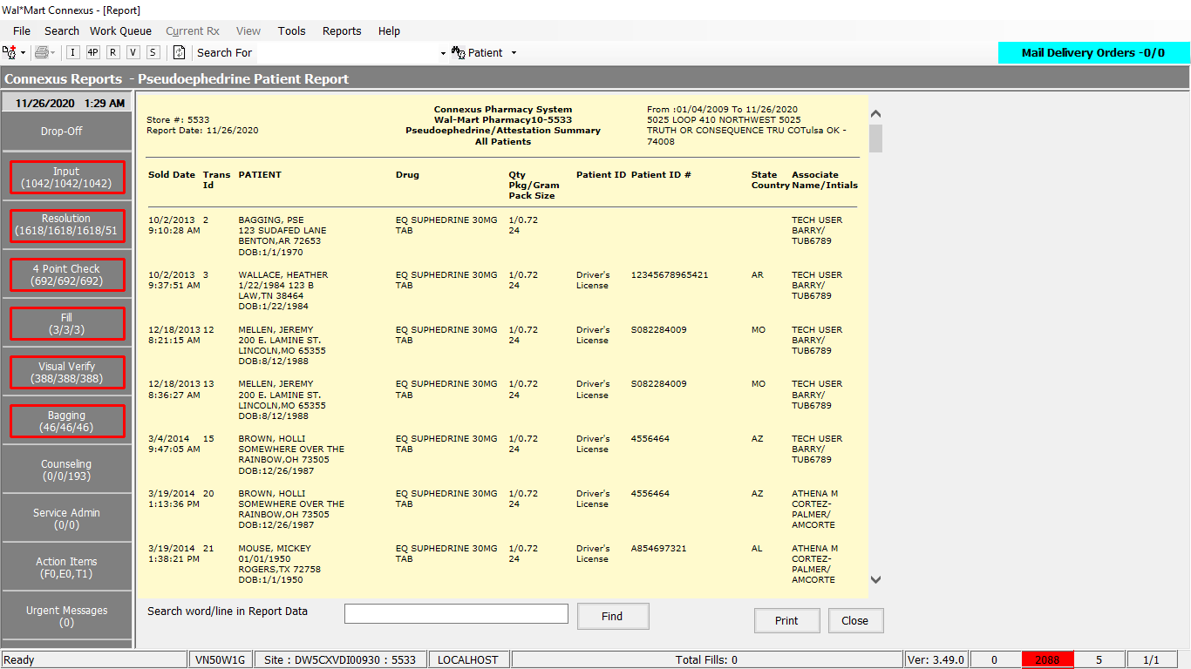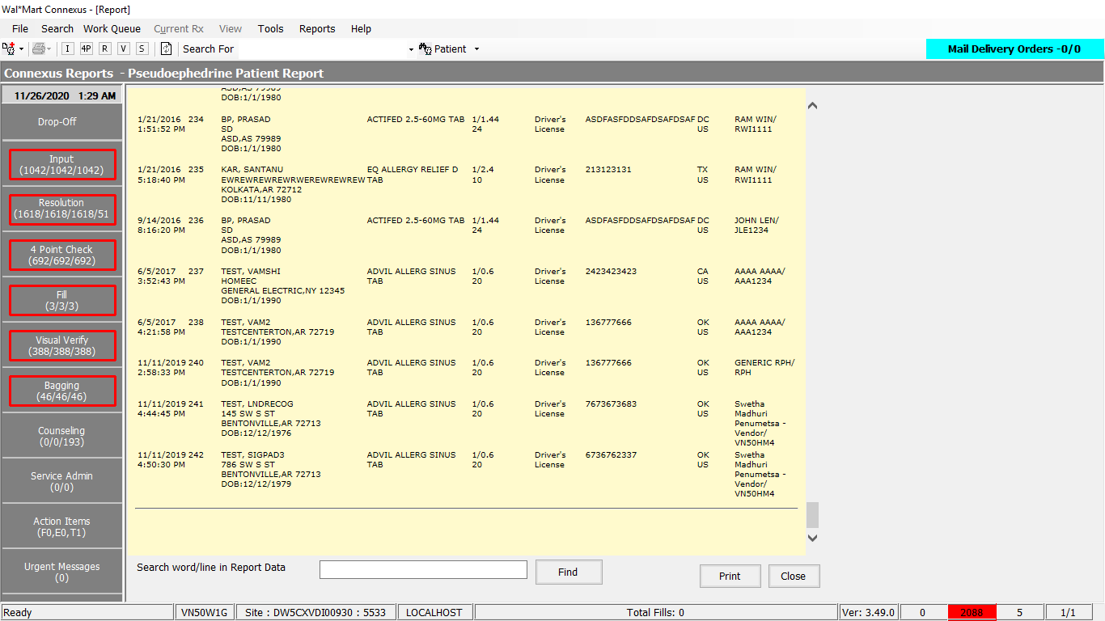

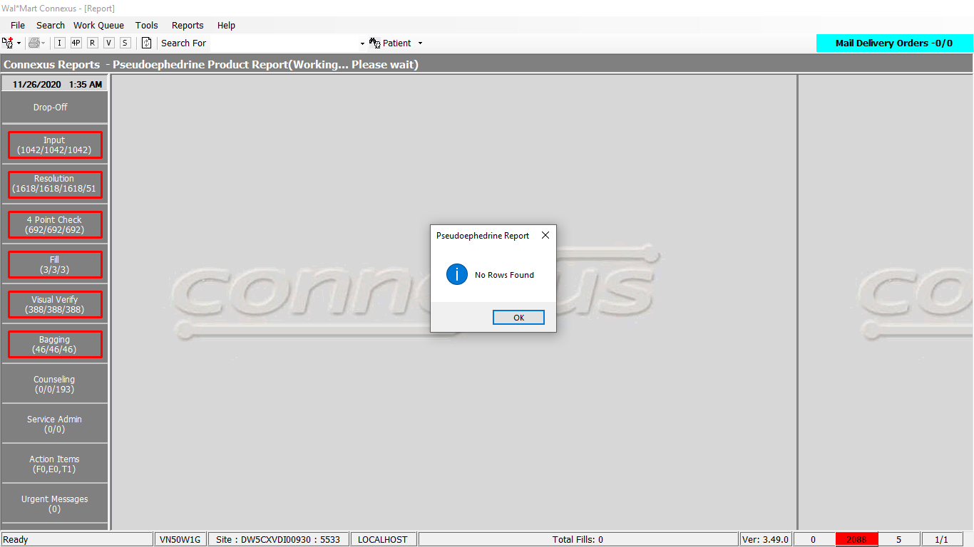

Query:

Friend Const GetRestrictedTransByPatients As String = "SELECT rt.rstr_txn_id, rt.txn_ts, p.patient_id, rti.mds_fam_id, " &

" rti.item_each_qty, rti.item_lot_nbr, TRIM(p.last_name) || ', ' || TRIM(p.first_name)patientname, " &

" p.birth_date, pp.short_name, pi.upc_nbr, (pi.inner_pack_qty)packsize, " &

" sa.user_descr, sa.userid, subj.address_line_1, " &

" subj.address_line_2, subj.city_name, subj.state_prov_code Addrstate_code, subj.postal_code, pir.restrict_value, " &

" pr.references_seq_nbr, pr.reference_nbr, ia.state_prov_code, " &

" pct.code_desc refDesc, " &

" pct1.code_desc govtIdDesc, " &

" gov.govt_id_doc_id govtid, " &

" gov.govt_id_number govtidnbr, " &

" ia1.state_prov_code govtIssueState, " &

" ia.country_code,ia1.country_code govtCountryCode " &

" FROM subject_address subj, rstr_txn rt, rstr_txn_item rti, rstr_txn_response rtrs, " &

" pharmacy_offering:pharmacy_product pp, patient p, " &

" phm_appl_security:system_user sa, pharmacy_offering:pharmacy_item pi, " &

" pharmacy_offering:phm_item_restrict pir, " &

" OUTER (patient_reference pr, " &

" issuing_agency ia, pharmacy_code_txt pct), " &

" OUTER (rstr_txn_request rtrq, govt_id_document gov, pharmacy_code_txt pct1, issuing_agency ia1) " &

" WHERE rt.rstr_txn_id = rtrs.rstr_txn_id " &

" AND rtrs.patient_id = rtrq.patient_id " &

" AND rtrs.request_ts = rtrq.request_ts " &

" AND rt.rstr_txn_id = rti.rstr_txn_id " &

" AND rtrq.govt_id_doc_id= gov.govt_id_doc_id " &

" AND rt.patient_id = p.patient_id " &

" AND rti.mds_fam_id = pi.mds_fam_id And pi.product_mds_fam_id = pp.product_mds_fam_id " &

" AND rt.txn_assoc_userid = sa.UserId " &

" AND subj.subject_id = p.patient_id " &

" AND sa.store_nbr Is NULL " &

" AND subj.subject_type_code= ?" &

" AND subj.addr_type_code = p.dflt_addr_type_cd " &

" AND rti.mds_fam_id = pir.mds_fam_id " &

" AND pi.mds_fam_id = pir.mds_fam_id " &

" AND p.patient_id = pr.patient_id " &

" AND pr.references_seq_nbr= rt.references_seq_nbr " &

" AND pr.issue_agency_code = ia.issue_agency_code" &

" AND pr.reference_code = pct.code_id " &

" AND gov.govt_id_doc_type = pct1.code_id " &

" AND pr.reference_code In (601, 603, 604, 605, 621,606) " &

" AND gov.govt_id_doc_type IN (601, 603, 604, 605, 621,606) " &

" AND pir.restrict_type_code = ?" &

" AND gov.issue_agency_code = ia1.issue_agency_code " &

" AND Date(rt.txn_ts) >= ?" &

" AND Date(rt.txn_ts) <= ?"

DAL:

Public Function GetRestrictedTransByPatients(ByVal siteId As Integer, ByVal startDate As DateTime, ByVal endDate As DateTime, Optional ByVal patientId As Integer = 0, Optional ByVal sortOrder As Integer = 0) As List(Of RestrictedTransactionListBE) Implements ITrackerDAL.GetRestrictedTransByPatients

Using (New Tracer(ConnexusCommonConstants.ConnexusTracer))

Dim querySQL As New StringBuilder

Dim identificationInfo As PatientPSEIdentificationBE

Dim paramList As New List(Of DbParameter)

querySQL = querySQL.Append(TrackerQueries.GetRestrictedTransByPatients)

'Adding parameters to param list

paramList.AddParameter(DbType.Int16, SubjectCodeType.SubjCodeTypePatient)

paramList.AddParameter(DbType.Int16, PseudoGramRestrictCodes.RestrictDrugGramsType)

paramList.AddParameter(DbType.String, String.Format(CultureInfo.InvariantCulture, "{0:MM/dd/yyyy}", startDate))

paramList.AddParameter(DbType.DateTime, String.Format(CultureInfo.InvariantCulture, "{0:MM/dd/yyyy}", endDate))

If patientId <> 0 Then

querySQL.Append(" AND p.patient_id = ?")

paramList.AddParameter(DbType.Int32, patientId)

End If

If sortOrder = 0 Then

'Sort by default SOLD DATE

querySQL.Append(" ORDER BY rt.txn_ts ")

Else

'Sort by patient name

querySQL.Append(" ORDER BY 7")

End If

Dim listRestrictedTransByPatientsBE As New List(Of RestrictedTransactionListBE)

'Execute query

Using dr As IDataReader = ExecuteReader(DatabaseEnum.rx21c, siteId, querySQL.ToString, paramList)

While dr.Read

Dim restrictedTransactionListBE As New RestrictedTransactionListBE

restrictedTransactionListBE.RestrictTransId = dr.GetValueOrDefault(Of Int32)("rstr_txn_id")

restrictedTransactionListBE.TxnTs = dr.GetValueOrDefault(Of DateTime)("txn_ts")

restrictedTransactionListBE.PatientId = dr.GetValueOrDefault(Of Int32)("patient_id")

restrictedTransactionListBE.MdsFamId = dr.GetValueOrDefault(Of Int32)("mds_fam_id")

restrictedTransactionListBE.ItemEachQty = dr.GetValueOrDefault(Of Int16)("item_each_qty")

restrictedTransactionListBE.ItemLotNbr = dr.GetValueOrDefault(Of String)("item_lot_nbr").SafeTrim()

restrictedTransactionListBE.PatientName = dr.GetValueOrDefault(Of String)("patientname").SafeTrim()

restrictedTransactionListBE.BirthOfDate = dr.GetValueOrDefault(Of DateTime?)("birth_date")

restrictedTransactionListBE.ShortName = dr.GetValueOrDefault(Of String)("short_name").SafeTrim()

restrictedTransactionListBE.UpcNbr = dr.GetValueOrDefault(Of Decimal?)("upc_nbr")

restrictedTransactionListBE.PackSize = dr.GetValueOrDefault(Of Decimal)("packsize")

restrictedTransactionListBE.UserDescription = dr.GetValueOrDefault(Of String)("user_descr").SafeTrim()

restrictedTransactionListBE.UserId = dr.GetValueOrDefault(Of String)("UserId").SafeTrim()

restrictedTransactionListBE.CountryCode = dr.GetValueOrDefault(Of String)("country_code").SafeTrim()

Dim govtId = dr.GetValueOrDefault(Of Int32)("govtid")

'Start Changes : <PBI000000003133> changed by Infosys Support team on 04 Sep 2014

'Calling Seperate Function for fetching Patient License and State information

'If reference seq number is NOT NULL, correct ID has been captured. Get corresponding details

'Else, Correct has not been captured. So, get the first ID available on profile.

If (dr.GetValueOrDefault(Of Short)("references_seq_nbr")) > 0 Then

restrictedTransactionListBE.ReferenceSeqNbr = dr.GetValueOrDefault(Of Short)("references_seq_nbr")

restrictedTransactionListBE.ReferenceNbr = dr.GetValueOrDefault(Of String)("reference_nbr").SafeTrim()

If Not String.IsNullOrEmpty(dr.GetValueOrDefault(Of String)("state_prov_code").SafeTrim()) Then

restrictedTransactionListBE.State = dr.GetValueOrDefault(Of String)("state_prov_code").SafeTrim()

If String.Equals(restrictedTransactionListBE.State.Trim(), ServicesCommonConstants.USG) Then

restrictedTransactionListBE.State = String.Empty

End If

End If

restrictedTransactionListBE.ReferenceCode = dr.GetValueOrDefault(Of String)("refDesc").SafeTrim()

Else

restrictedTransactionListBE.ReferenceSeqNbr = 0

identificationInfo = GetLicensesByPatientId(restrictedTransactionListBE.PatientId, siteId)

If Not identificationInfo Is Nothing Then

restrictedTransactionListBE.ReferenceCode = identificationInfo.ReferenceCodeDesc

restrictedTransactionListBE.ReferenceNbr = identificationInfo.ReferenceNbr

If identificationInfo.State.Trim() = ServicesCommonConstants.USG Then

restrictedTransactionListBE.State = String.Empty

Else

restrictedTransactionListBE.State = identificationInfo.State.Trim()

End If

End If

End If

'If the pickup person license type details are present in new govt_id_document table,

'then populate the details based on this table.

If govtId > 0 Then

restrictedTransactionListBE.ReferenceNbr = dr.GetValueOrDefault(Of String)("govtidnbr").SafeTrim()

restrictedTransactionListBE.ReferenceCode = dr.GetValueOrDefault(Of String)("govtIdDesc").SafeTrim()

restrictedTransactionListBE.State = dr.GetValueOrDefault(Of String)("govtIssueState").SafeTrim()

restrictedTransactionListBE.CountryCode = dr.GetValueOrDefault(Of String)("govtCountryCode").SafeTrim()

End If

'End Changes : <PBI000000003133> changed by Infosys support team on 04 Sep 2014

restrictedTransactionListBE.AddressLine1 = dr.GetValueOrDefault(Of String)("address_line_1").SafeTrim()

restrictedTransactionListBE.AddressLine2 = dr.GetValueOrDefault(Of String)("address_line_2").SafeTrim()

restrictedTransactionListBE.CityName = dr.GetValueOrDefault(Of String)("city_name").SafeTrim()

restrictedTransactionListBE.AddressStateCode = dr.GetValueOrDefault(Of String)("Addrstate_code").SafeTrim()

restrictedTransactionListBE.PostalCode = dr.GetValueOrDefault(Of String)("postal_code").SafeTrim()

restrictedTransactionListBE.RestrictValue = dr.GetValueOrDefault(Of String)("restrict_value").SafeTrim()

listRestrictedTransByPatientsBE.Add(restrictedTransactionListBE)

End While

End Using

If listRestrictedTransByPatientsBE.Count = 0 Then

listRestrictedTransByPatientsBE = Nothing

End If

Return listRestrictedTransByPatientsBE

End Using

End Function